Exam 2 study guide
- Describe the anatomical barrier components of the innate immunity.
  - Consists of skin and mucous membranes, which include the mucosal epithelia that line the respiratory, gastrointestinal, and urogenital tracts; synthesize and release peptides and proteins with antimicrobial activity (
  - Skin: antimicrobial peptides, fatty acids in sebum
  - Epidermis and Dermis
    - Epidermis: thin outer layer consisting of keratin
    - Dermis: composed of connective tissue and contains blood vessels, hair follicles, sebaceous glands, and sweat glands.
- How does normal flora assist with resistance to infection?
  - Competes with invading mirobes, fluid/feces expelled from rectum
- What are some of the limitations of anatomical barriers?
  - Breaks in the skin
  - Easily penetrated by biting insects
  - Specialize adaptations
- Describe cells and events/responses that link innate immunity to adaptive immunity.
  - When bacteria interacts with an antibody, it exerts an effect on phagocytic cells of innate immunity thus activating innate mechanism making adaptive response to provoke frequent inflammation either acute or chronic
- What are pattern recognition receptors and what do they detect?
  - This are receptors in body cells that detect infection or tissue damage
- What are some events that occur during inflammation?
- Exudation which involve flow of body fluids from intravascular space
- Vascular stasis that slows down blood flow in the body
- Vasodilation that leads to more blood flow in the area of inflammation
- Describe antimicrobial peptides and give examples.
- This is group of biological active molecules with multidimensional properties that enable them function as effectors molecules such as signaling.
- Examples include andropin, moricin, dermaseptin etc
- Give examples of receptors of the innate immune system and their targets.
- Mannose-binding lectin that targets microbial surface
- NF_{K}B targets the nucleus of the bacteria
- Dectin-1 targets the bacterial cell walls
- What are toll-like receptors?
This are receptors associated with a variety of adaptor molecules that help to convert recognition of microbes into signal which activates specific gene transcription within the cell
- Examples of target ligands for the toll-like receptors.
- Dopamine in brain and oxygen in blood stream
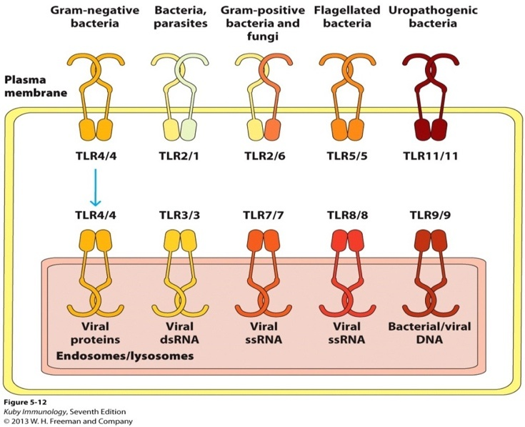
- Discuss the characteristics of the cell types that mediate innate immunity.
They are motile
They lack hemoglobin
They have nucleus
- Describe oxidative attack.
  - Employs reactive oxygen species (ROS) and reactive nitrogen species (RNS).
  - Generated by the NADPH phagosome oxidase (phox) enzyme complex
- Describe nonoxidative attack.
  - Defenses are deployed when neutrophil granules fuse with phagosomes.
  - Composed of Bactericidal/permeability-increasing protein, Proteases, Lysozyme, Defensins, and cathelicidins

Chapter 3

- What is vectorial redistribution of the secretory apparatus?
It is an axis along which cell division becomes ogarnized
- What are factors that can influence the cell becoming more or less susceptible to the actions of a ligand?
  - Increasing or decreasing the expression of the receptor for that ligand
- Compare and contrast affinity and avidity.
  - Affinity: a strength of that individual pairing
  - Avidity: strength of multiple interactions
  - an interaction may have weak affinity, but high overall avidity
- What are some of the changes in the receptor that occurs once the ligand binds to the receptor?
  - Conformational: shape change
  - Dimerization: formation of a dimer
  - Covalent modification: regulating the activity of a protein (usually an enzyme)
- Understand the importance of having multiple noncovalent bonds between receptor and ligand.
  - Noncovalent bonds are weak bonds crucial for biochemical process they play a major role in interaction of receptor cells and lingad cells
- What is meant by multivalent with respect to antigen and antibody?
  - It refers to having many attachment points at which antigens and antibodies can bind
- The role of receptor dimerization, receptor multimerization and lipid rafts in signal initiation.
  - Receptor dimerization is often a result in multimerizarion
  - Lipid rafts acts as platform for signal transmission
- Significance and examples of co-receptors and accessory molecules for BCR and TCR.
  - CD4 regulates T-cells and specify MHC class II
  - CD8 that specify MHC class I
- What is the need for the Igα/Igβ dimer in BCR signaling?
  - They are needed for B-cell development, activation, proliferation, differentiation and immune response
- What is the difference between mIg and antibody?
  - Antibody floats in body fluids thus it lacks transmembrane domain while mlg has a transmembrane domain for attachment on B-cell
- Describe the general structure of an antibody.
  - It has four peptide chains: one pair of light polypeptide chain and a pair of heavy polypeptide chain joined to form Y-shaped molecule
- What features do glycosylation of antibody provide?
  - Modification ( glycosylation) of proteins and lipids that do not fold correctly on macromolecule
- Compare and contrast BCR and TCR.
  - BCR binds to carbohydrates while TCR binds to peptides
  - Both BCR and TCR molecules associate with the immune system of the human body
- Role of the CD3 complex.
They are used in intracellular signaling and TCR surface expression
- Components of the TCR-CD3 complex and their interactions with each other.
  - CD3_{Y}
  - CD3-delta
The associate with T-cell receptors and zeta chain to generate activation signal
- What is the predominant TCR found in the body?
  - Surface of T-cells
- CD4 and CD8 characteristics.
  - They are found in perivascular space and saporadically in the parenchyma
- Gamma delta T cells characteristics (There were approximately 8 slides discussing these cells)
  - They have a distinctive T- cell receptor on their surface
- CD1 molecule characteristics
  - It has transmembrane domain
  - I has an intracellular trail
  - It has isoforms composed of heavy chain containing 3 extracellular domain
- Receptor – ligand affinity rankings.
  - 8.10326
- T-cell interactions other than that of the TCR and MHC molecule.
  - CD40L-CD40
  - DC

